**Setting Up Hybrid Framework**

To use hybrid framework, ensure the following pre requisites are met

* **JDK and JRE (install and set environment variable properly)**
* **IDE: Eclipse (copy paste set up and open eclipse)**
* **Web Server: Apache Tomcat(install with port 8282)**
* **Java build and deployment tool: ANT**
* **Browser: Mozilla FireFox : Version 35 or below**
* **TestNG (add at help-install s/w=testng - http://beust.com/eclipse)**

After the installation of Eclipse

1. Create a workspace to have your project files.
2. Browse and open the location in eclipse

There should be 5 packages

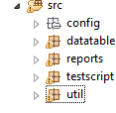

**Config :**

Controller: Test data excel

Object Properties: Objects of the webElement

Application.log : Logs of the application

config.properties: URL in which the testing has to be done



Db_data

**Datatable**



**Xfile Reader**:

Excel reader file

Reports consists of



**ReportUtil.java:**

File regarding the Test reports

**Util**

; 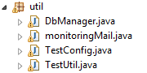

DbManagermail: DB related methods

Monitoring Mail: Mail sending on test failure

TestConfig: DB Config details

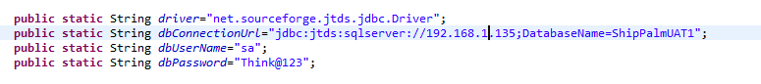**TestNG.xml**

Controller and object file name of the corresponding test module should be given in testing.xml

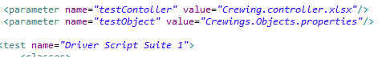

**Apache Tomcat:**

While installing Apache Tomcat ,

* Http Port# should be set as **8282**. Existing JRE path should be correct..
* Create 3 folders in the following location of Tomcat

C:\Program Files\Apache Software Foundation\Tomcat 8.0\webapps\ROOT



**File Writer**: Logs of the all the methods

**htmlpages:**Test reports

**screenshots**: screenshots of failed cases are placed here

Set these folder path in

**htmlpages =Testscript>Driverscript.java**



**screenshots= Util> testutil.java**



**File Writer =Testscript >Certificate.java**



**Importing Selenium and Hybrid Libraries**

* Right Click on Main project
* Click on Build Path> configure Build Path>
* In the Libraries> Click on ‘Add External JARs’

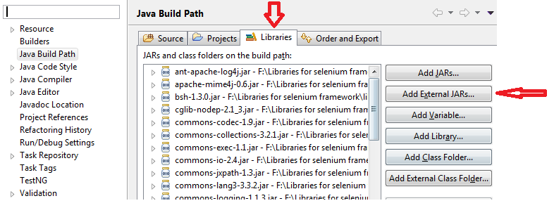

Installing Test NG in Ecclipse

Steps to follow:

1) Launch the Eclipse IDE and from Help menu, click “**Install New Software**”.

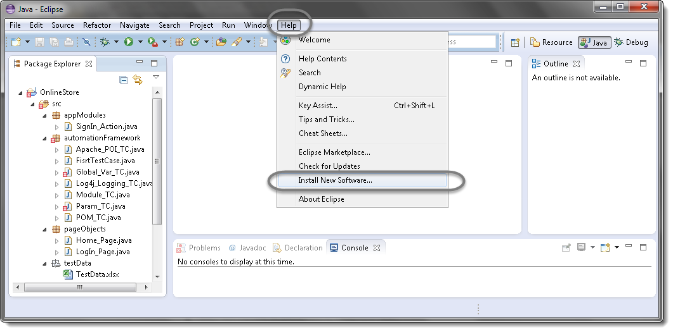

2) You will see a dialog window, click “**Add**” button.

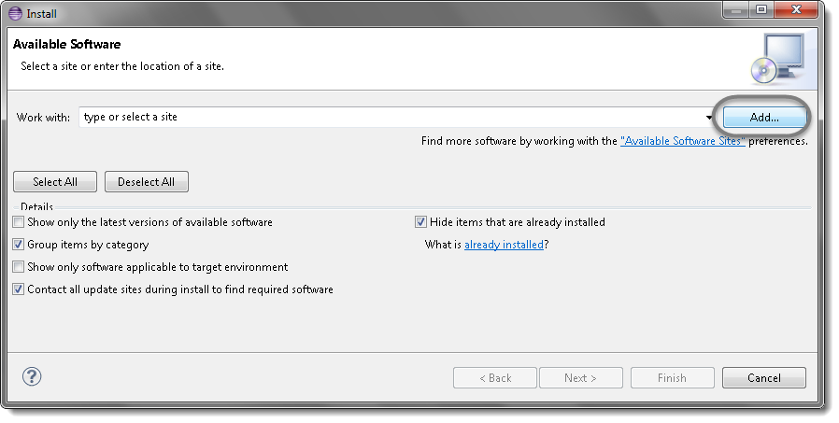

3) Type name as you wish, lets take “**TestNG**” and type “**http://beust.com/eclipse/**” as location. Click OK.

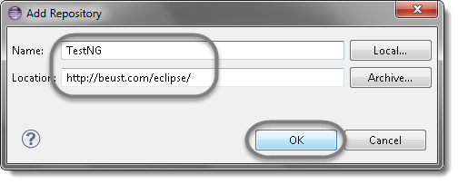

4) You come back to the previous window but this time you must see TestNG option in the available software list. Just Click TestNG and press “**Next**” button.

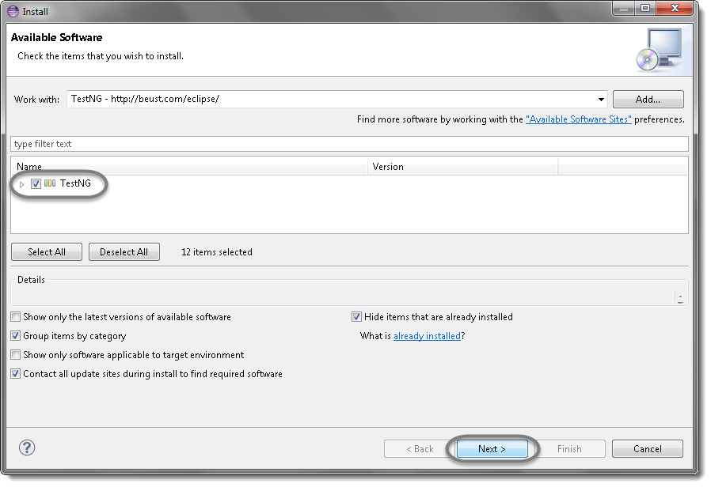

5) Click “**I accept the terms of the license agreement**” then click **Finish**.

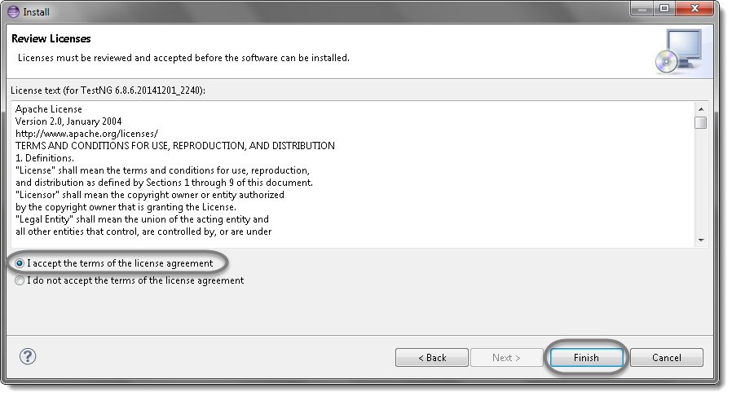

6) You may or may not encounter a Security warning, if in case you do just click **OK**.

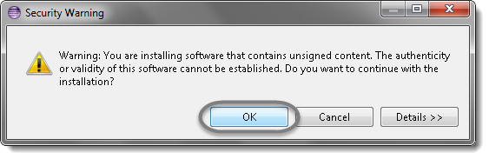

7) Click **Next** again on the succeeding dialog box until it prompts you to Restart the Eclipse.

8) You are all done now, just Click **Yes**.

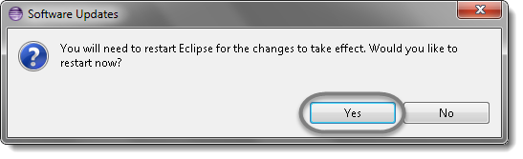

9) Proceed with your workplace.

10) After restart, verify if TestNG was indeed successfully installed. Right click on you project and see if**TestNG**is displayed in the opened menu.

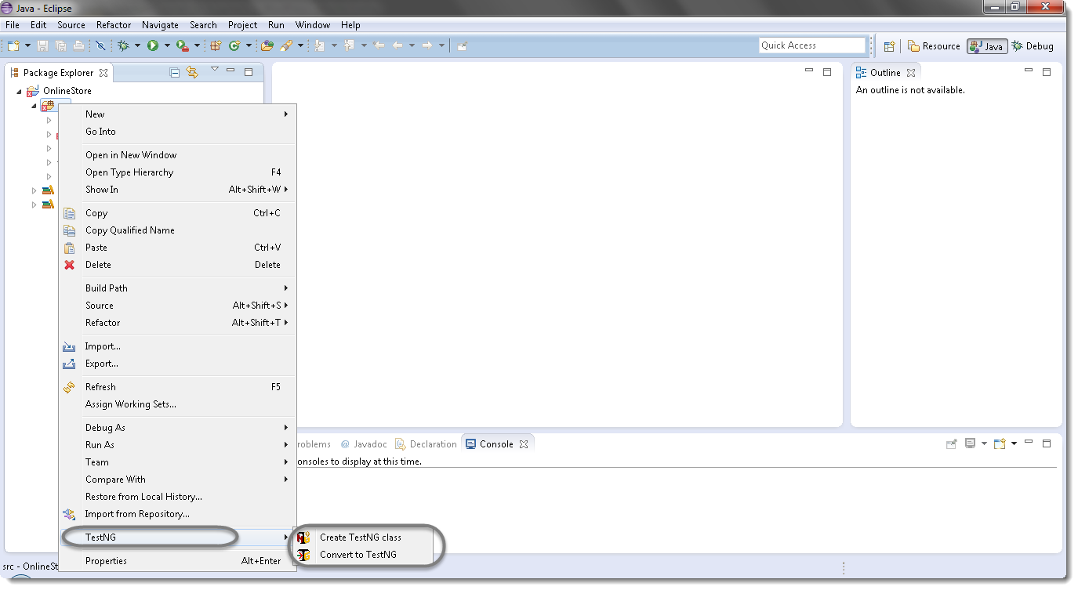

**Environment Variable Settings**

Right click My Computer> Advanced system settings> Environment variables

Set



ANT HOME: Set apache ant path

Path: Add theJDk /Bin folder path

Ensure that your JDK ans compatible with the current libraries